
Procedure 2025

ArcelorMittal Building Solutions France Procedure 1.1.1.7

DUE BFA

List of BFA groups

DISTRIBUTION activity :
  - ALTEMA
  - BELAYSOUD
  - BIGMAT
  - CHAUSSON
  - CMEM
  - GEDEX
  - IBANA composed of POINT P and ASTURIENNE (107441)
  - KDI
  - LARIVIERE
  - NESTA (003968)
  - NICODEME
  - ORCAB
  - SAMSE
  - SOCODA
  - SOGEDESCA

ENVELOPPE activity :
  - CANCE
  - CIBETANCHE
  - DSA
  - ESA
  - FACE
  - SMAC
  - SOPREMA

GROUP :
  - AMDS (108392)
  - AMCS (106463)

These different groups represent groupings of customers, sometimes with the same name, sometimes with several different customers but belonging to the same group.
Some have only one billing account, but include several agencies, while others have several different billing accounts
For each of these groupings, there is a variant in SAP that you need to use to process overdue invoices, except for NESTA, ASTURIENNE, AMDS and AMCS, where you simply need to use the customer account noted in brackets in the above list.
A follow-up has been created in K / Customer credit / BFA / 1. BFA follow-up

SAP extraction

On the SAP application, select "ECC Unity Production", then log on with your login and password:
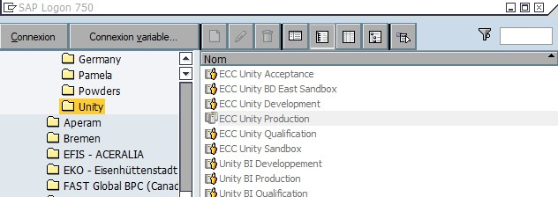
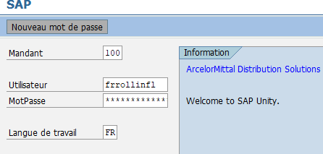

Go to Accounts Receivable => Account => Individual Customer Pos
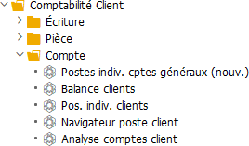
Tip: for easy access, you can also bookmark the most frequently used accounts: left-click on the line you wish to bookmark, then release the bookmark button.
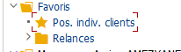

On the SAP home screen, select the FBL5N menu, fill in the company box with FR01, then click on the tab:

Select transaction FBL5N :
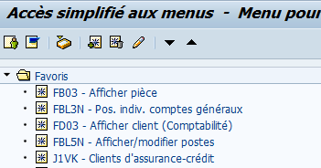

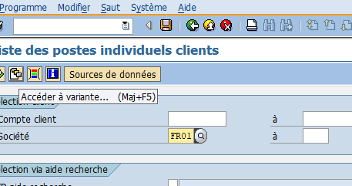

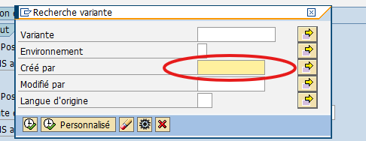


If you did not create the desired variant, delete the name entered in the "Created by" box, then validate.

To search for the desired variant, go to the variant names beginning with FR01, double-click on it and then F8 (execute).
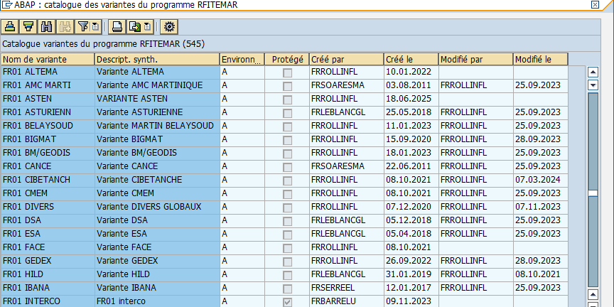

Let's take the case of FACE:
There are several FACE branches, all of which are billed to themselves, so there will be one SAP account per branch.
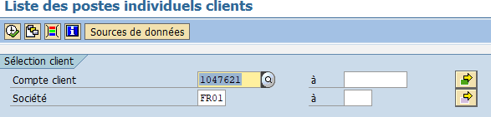
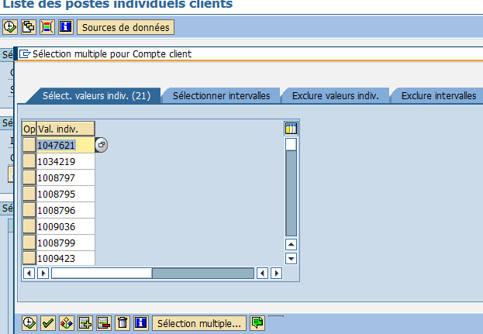
After double-clicking on the FACE variant, all the accounts entered in it will be listed:

In order to generate an account statement for each invoiced account, once the variant has been selected, check that the company code is FR01, set the current date in
"Open items" (without "." or "/"), check only "Standard items", then use the /FR01 Excel formatting, then validate with F8 (execute).
This formatting allows you to have a table for each SAP customer, with the columns already in
which will follow a logical direction:
SAP | Invoice no. | AR no. | Part | Part date | Due date | Amount incl. VAT | Comments

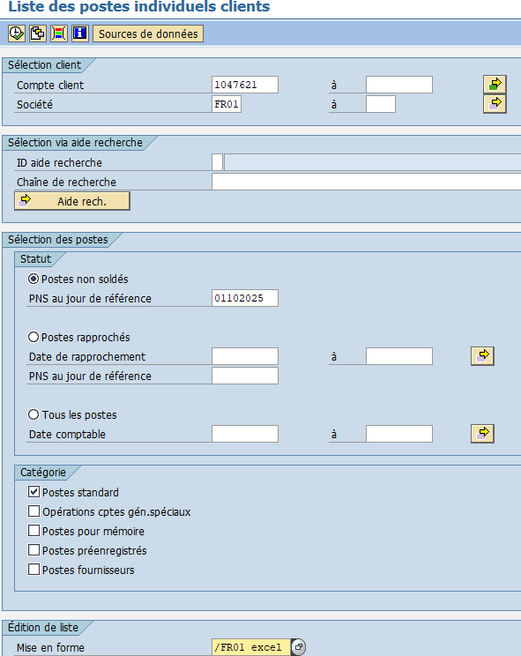


Once the table has been generated, you need to exclude the lines corresponding to the discount, if any.
To do this, select the "Text" column by clicking once on the column header, then click on "Set filter".

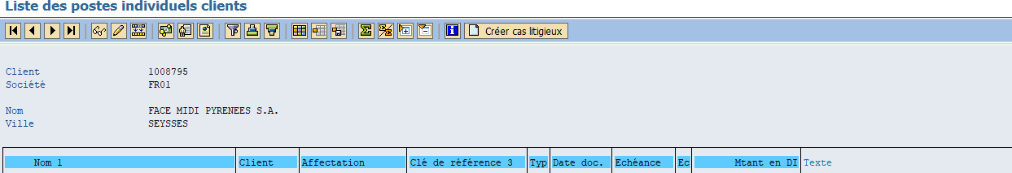
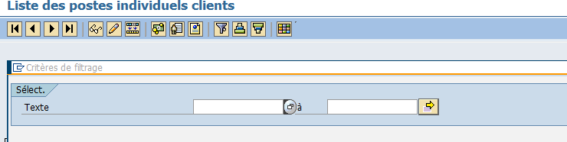


Go to the "Exclude indiv. values" tab, enter *RDU* to exclude all lines where the word RDU appears in the comments (RDUs will be adjusted internally, see procedure 1.3), then validate:

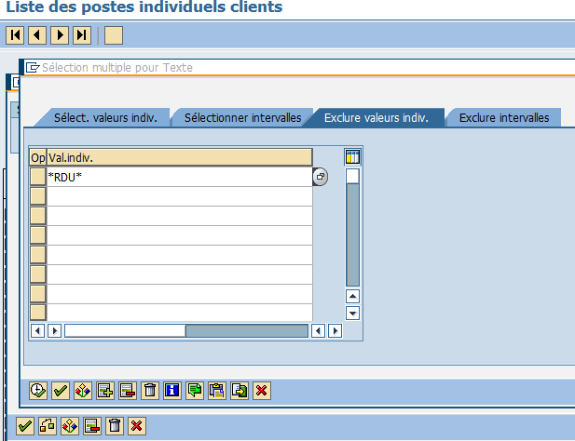


To select only due dates, click on the logo of one of the table rows.
then click on "Set filter":
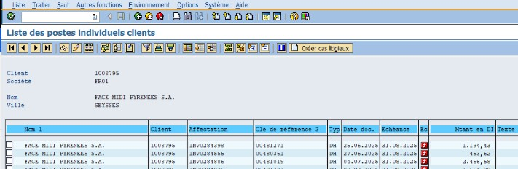


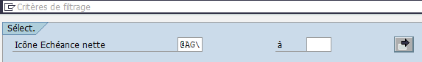

(the filter is automatically completed according to the box selected just before)
Then validate

Once the table is ready, we can export it in Excel format:
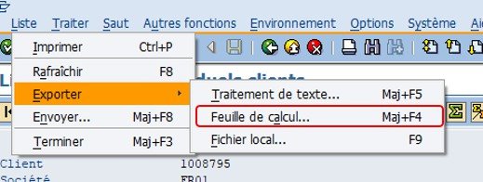

Choose the file to save the extraction to:
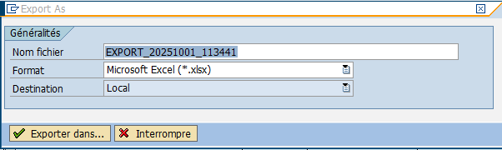

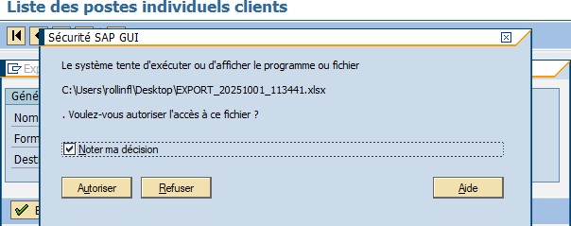

Table update

This extraction reflects the state of the account on the date entered, and will therefore enable us to
update the previous table
To do this, go to K / Customer credit / BFA / FACE (in our example) / 2025 (year in)
and open the most recent due date table:
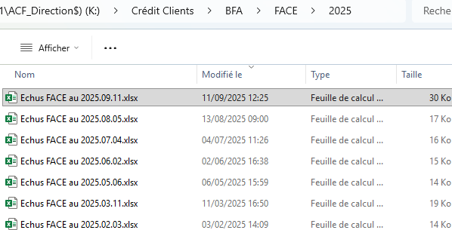

Once opened, this table must be updated according to the extraction performed.
previously :
- Delete lines that have been balanced
- Add lines that were not included in the previous version (new outstanding invoices, deductions, etc.).
- Distinguish between envelope and folding amounts (2 different columns)

Once this update is complete, you'll need to fill in the missing information.
Let's take this line as an example:

- Using the AR number, search for the relevant agency. In Sofie, go to the 03/01/09 menu, paste in the AR number and press ENTER :
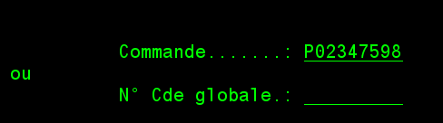

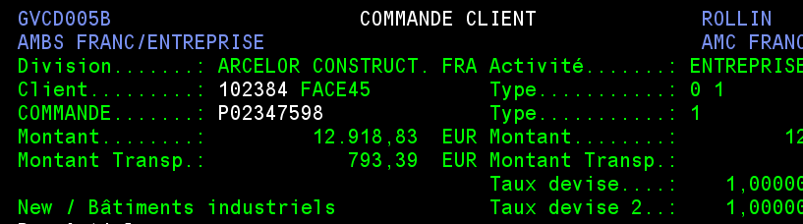

Enter the Sofie code and company name in the corresponding columns

Note: for the folding activity, you'll need to take the AR number and enter it in AX,
"Paste the AR and validate:

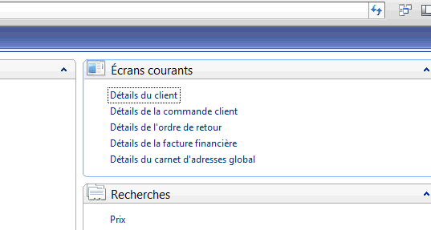

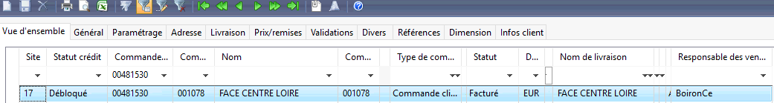

To find the Sofie code, click on the "Customer info" tab:
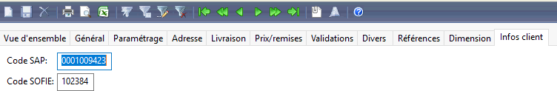

- With the Sofie code, go to the 03/01/05/07 menu to fill in the city and name of the traveling salesman:
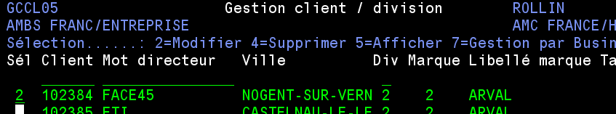

(If the city doesn't appear in full because it's too long, go to menu 03/01/05/01 to find the information).

Put 2 in front of the line and validate, then F6 to retrieve the salesperson's name:
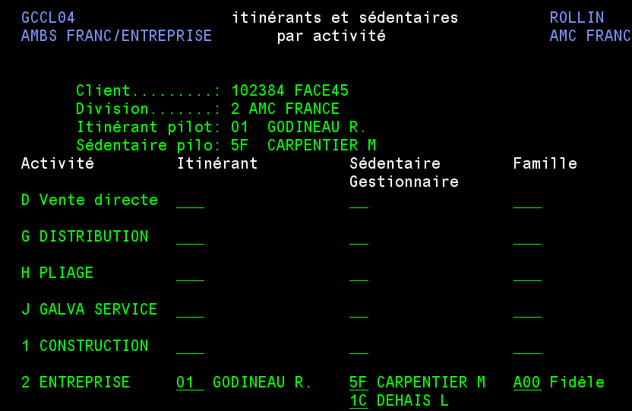

(For the Distribution activity, you'll also need to enter the
sales representative)

In document type, adjust the text exported by SAP:
- DH
  - Positive amount = invoice
  - Negative amount = credit note

- DG
  - Positive amount = deduction made by the customer on an invoice / partial payment
  - Negative amount = settlement, overpayment, double payment (see comments in "Text/Comments" column)

- Type of payment
  - E1 = bank transfer
  - E3 = check payment
  - E5 = bill of exchange settlement
  - E8 = credit card payment

Please note: for deductions, it is essential to check and fill in the information already entered in SAP by the accounting department. Let's take this example:

In this case, take the invoice number noted on the right in the "Comments" column and search for it in Sofie in the menu (14 / 03) :
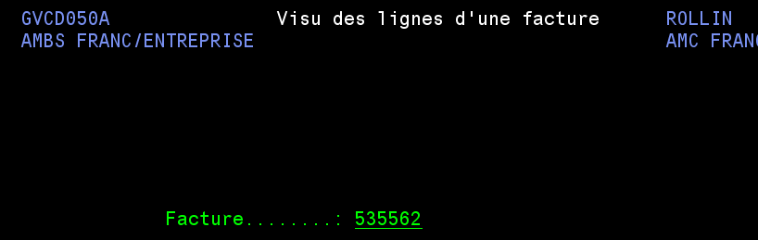
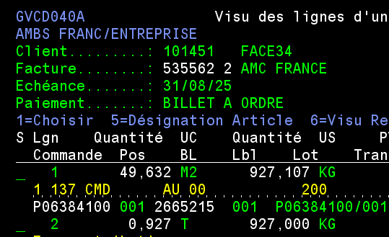

You can then enter the correct invoice number (format SF00xxxxxx) and AR number for this
deduction

Lastly, you'll need to filter the first line of the table, classify them by company name/customer name, and then sub-totals by agency.

Once all these steps have been completed, here is a visual for our FACE example:
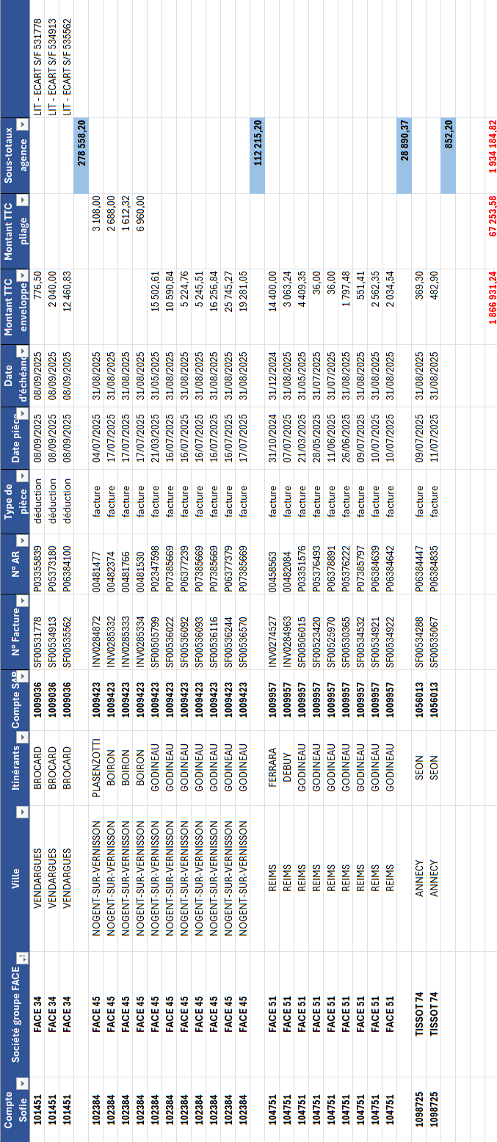

Follow-up table
In the BFA folder, you will therefore find a subfolder for each customer attachment, as well as a folder entitled "1. SUIVI BFA "
This file contains the various follow-ups carried out over the years
It groups together all customer attachments and allows you to note the date on which the
last point has been made.
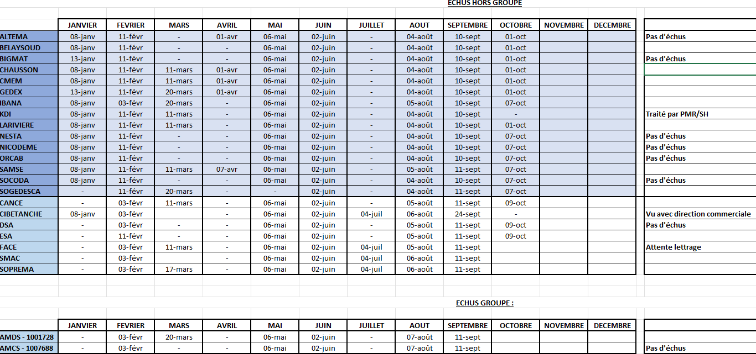

The comment column allows you to specify whether or not there are due payment, which already gives a
first visual via the table of overdue and non-overdue groups.
Specific comments may also be noted (handled by sales management, major dispute, etc.).
If new groups were to appear (information communicated by the people in charge
or sales management), then they should be added to this table as well.

On: 03/11/2025
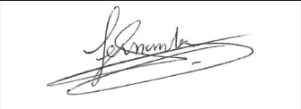
Procedure validated by : S. HERNANDEZ

